Project Initialization and Planning Phase

Date | 26 June 2026
Team ID
Project Name | Smart Lender
Maximum Marks | 3 Marks

Define Problem Statements (Customer Problem Statement ):




Example:
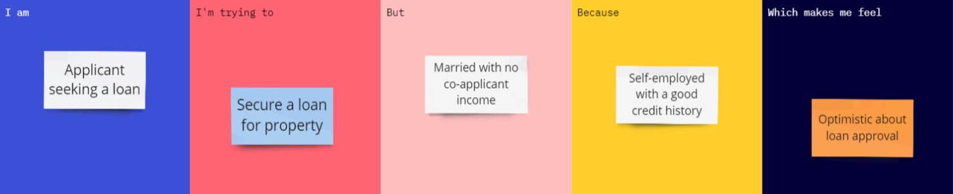

Problem  Statement  (PS) | I am (Customer) | I’m trying  to | But | Because | Which makes me feel
PS-1 | A self-employed individual seeking a business loan. | Secure a loan for business expansion. | My monthly income fluctuates. | I have a very strong credit history and high collateral. | Anxious about being rejected due to strict automated income rules.
PS-2 | A Bank Credit Officer. | Process 500+ loan applications per day. | The manual verification process is slow and biased. | I need to ensure high accuracy to avoid financial loss. | Overwhelmed and pressured by the high volume of paperwork.
PS-3 | A first-time home buyer. | Get a quick pre-approval for a mortgage. | I don't know which factors are affecting my eligibility. | I want to plan my house hunt based on a realistic budget. | Confused and uncertain about my financial standing.

